Lab Exercise: Multidimensional Arrays in C/C++
Solve the below problems in C/C++ and give the time and space complexities

WAP to solve the following 2D Array in C/C++

1) Create a Null Matrix of 3X3
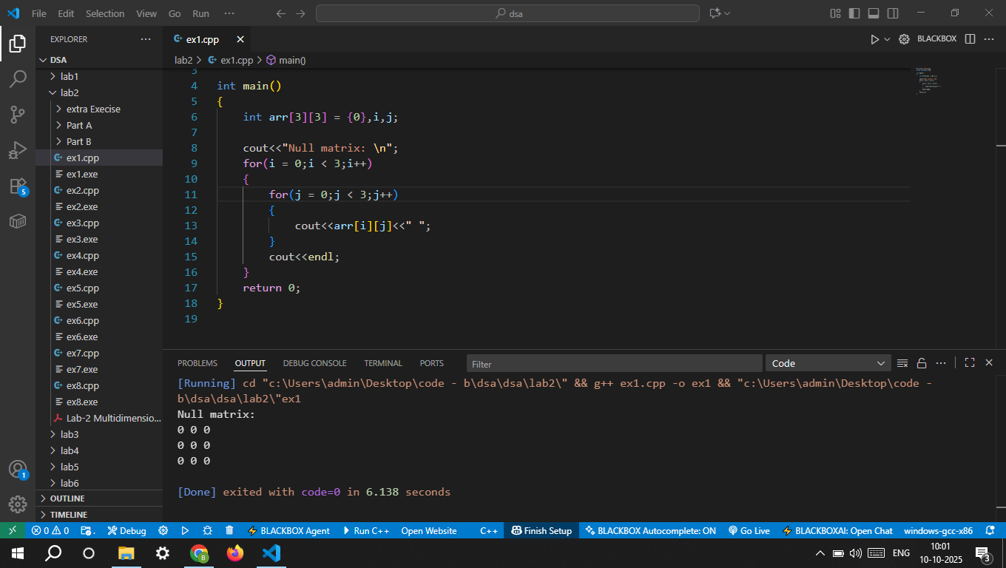

2) Create an Identity Matrix of 4X4 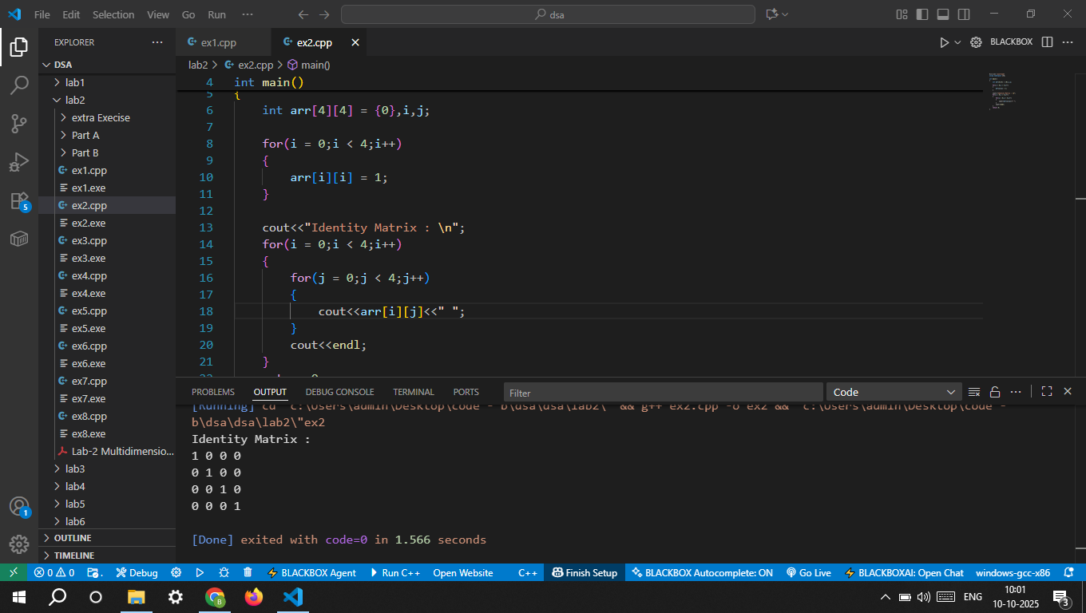

3) Check that a matrix is Square or Not
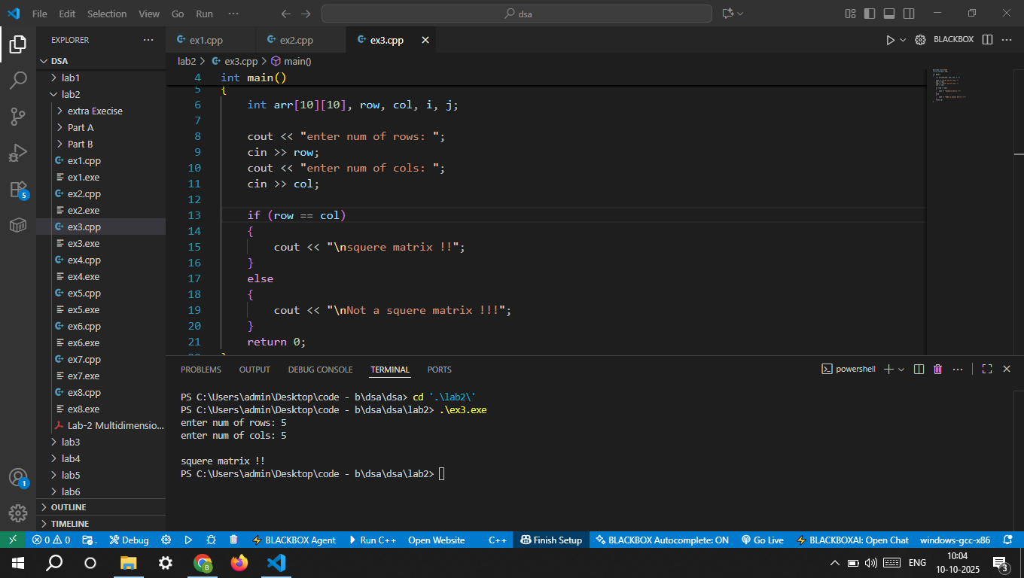

4) Check that a matrix is Identity Matrix or Not.
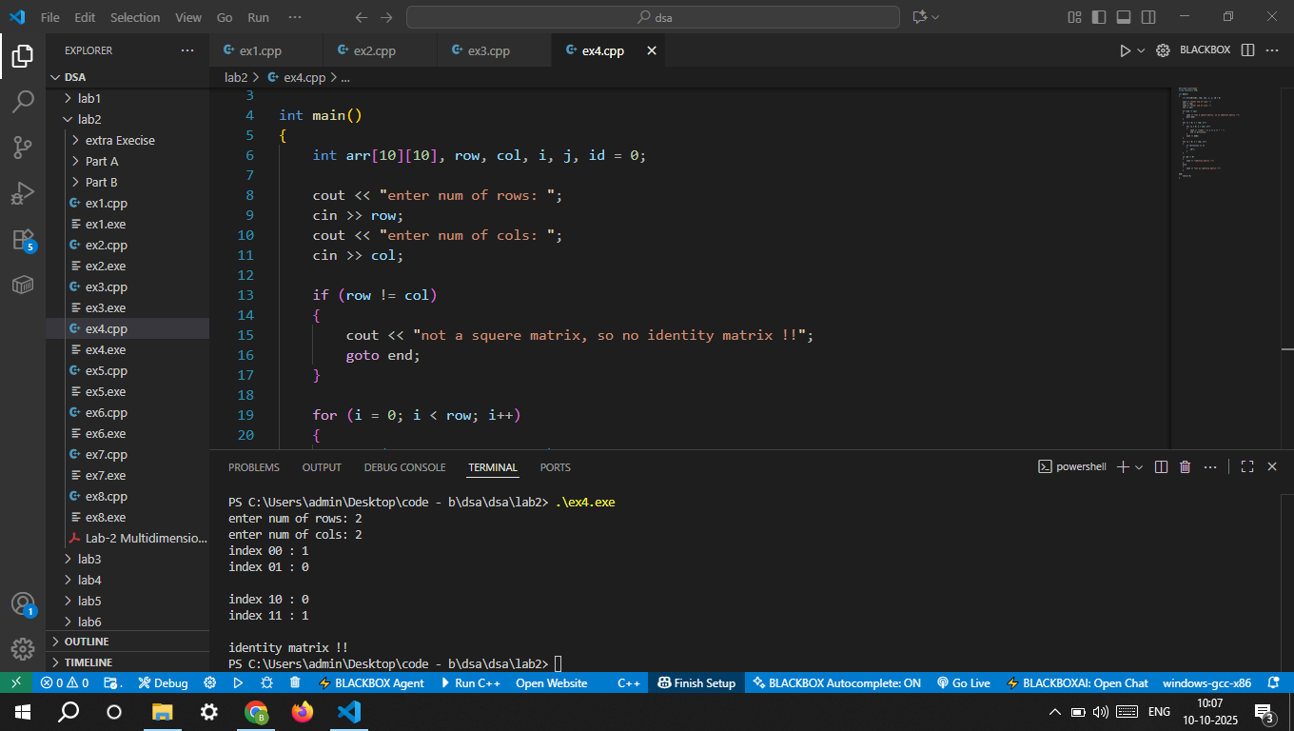

5) Write a program to implement a 2D Array by defining its elements and display the elements of the 2D Array. 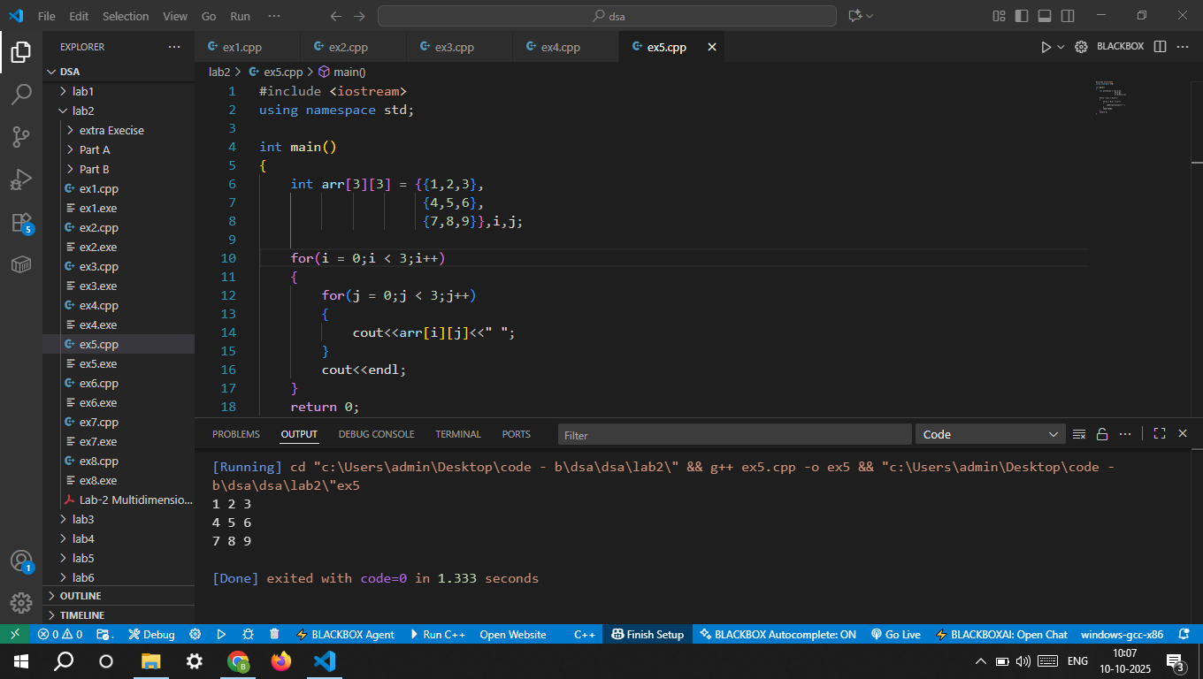
6) Write a program to implement a 2D Array by taking inputs from user and display the elements of the 2D Array.
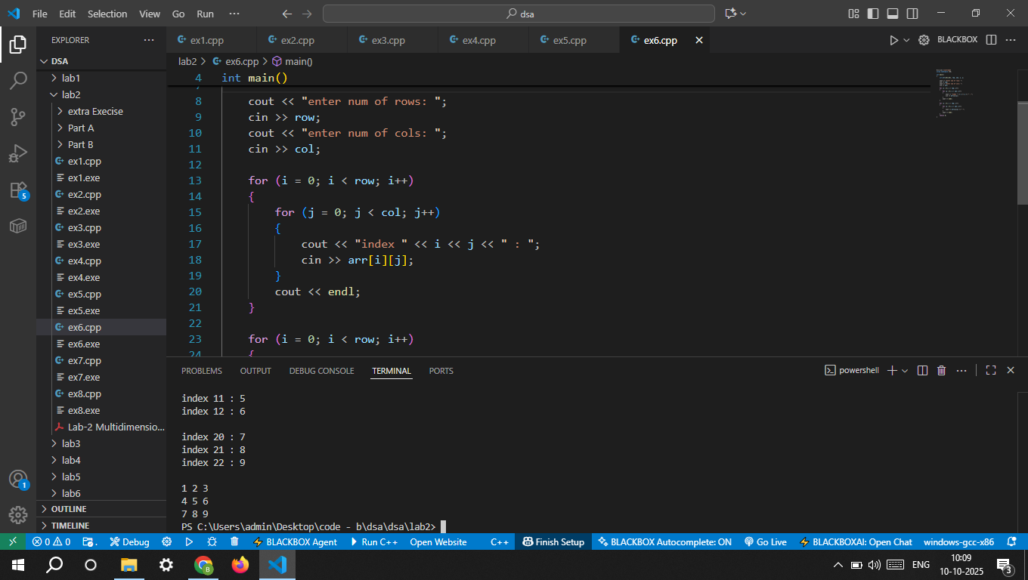

Part A: 2D Arrays (Matrices)
Problem 1: Matrix Addition Write a C/C++ program to:
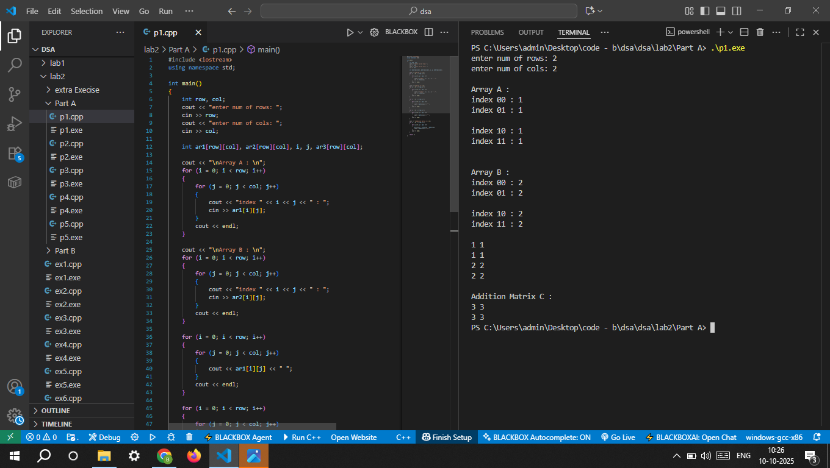

Problem 2: Matrix Multiplication Write a program that:
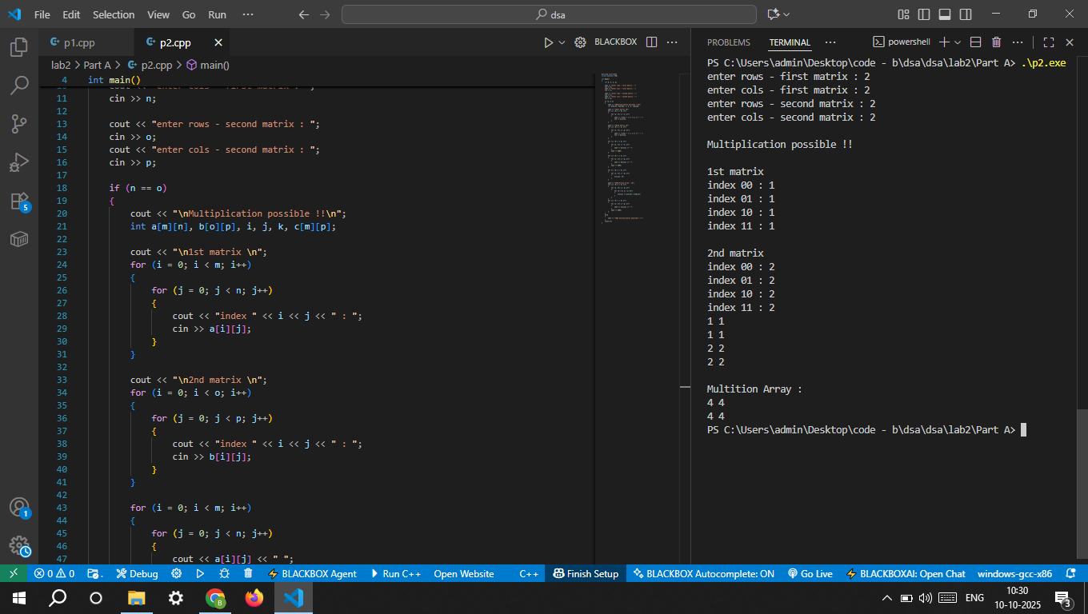

Problem 3: Transpose of a Matrix Create a program to: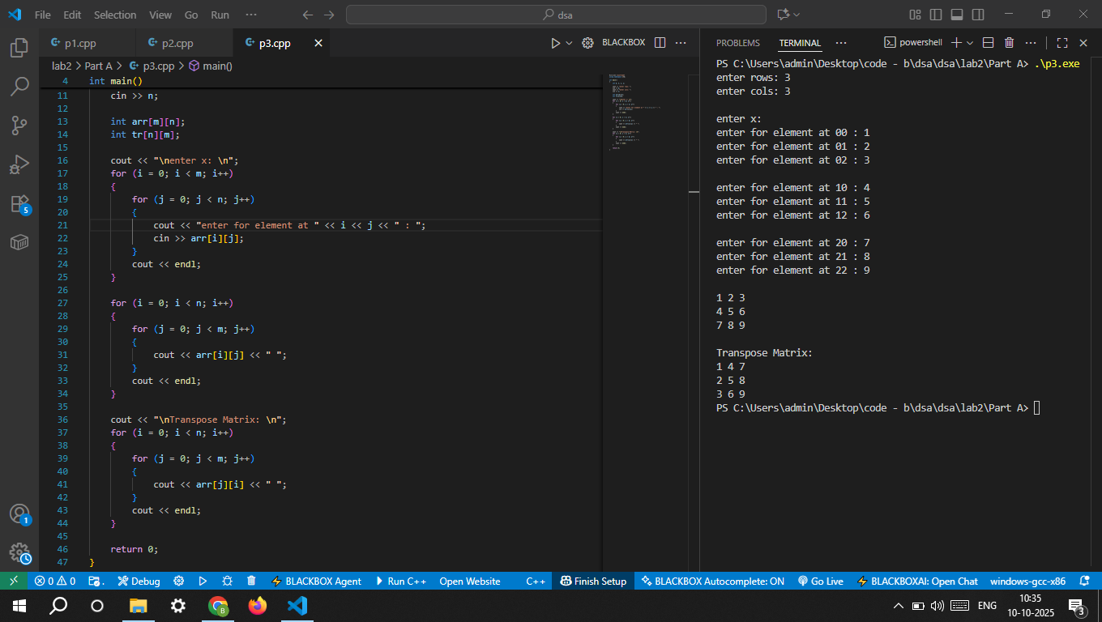

Problem 4: Determinant of a 2x2 Matrix Write a program to compute the determinant of a 2x2 matrix: Determinant=a11a22−a12a21Determinant=a11a22−a12a21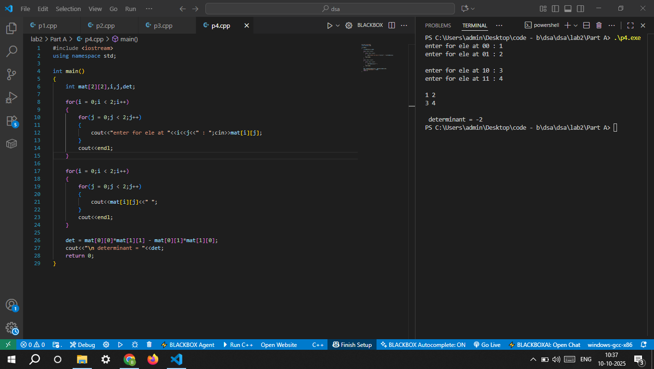

Problem 5: Saddle Point of a Matrix Find and print all saddle points in a matrix. A saddle point is the minimum element in its row but the maximum in its column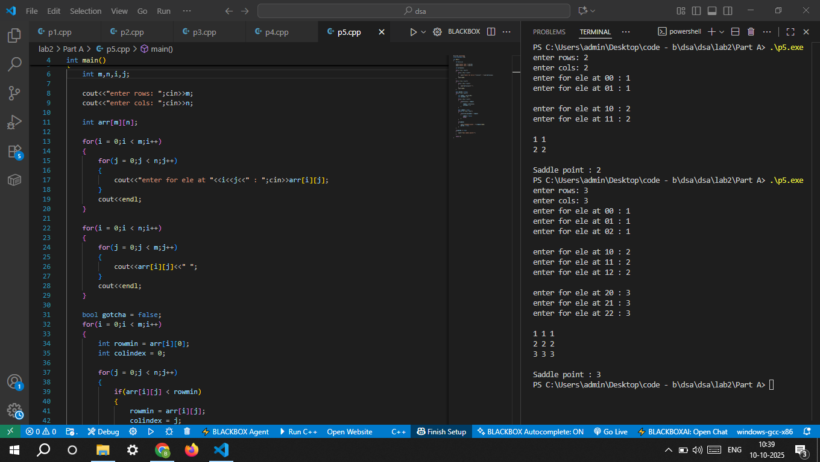

Part B: 3D Arrays

Problem 6: Traversal of a 3D Array Declare and initialize a 3D array of size 2×3×4. Write a program to: • Display all elements of the array. • Print the elements layer by layer. 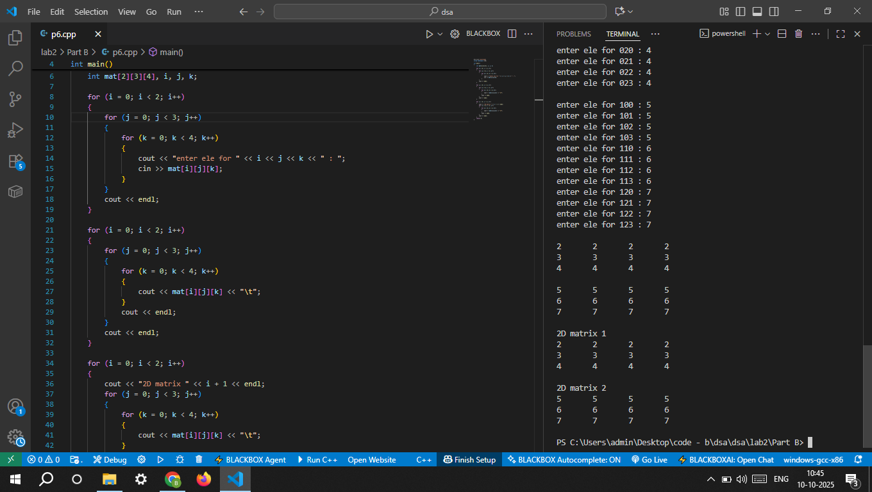

Problem 7: Search in a 3D Array Write a program that: • Accepts a 3D array of size 3×3×3 from the user. • Searches for a specific element entered by the user. • Displays its position(s) (layer, row, column) if found.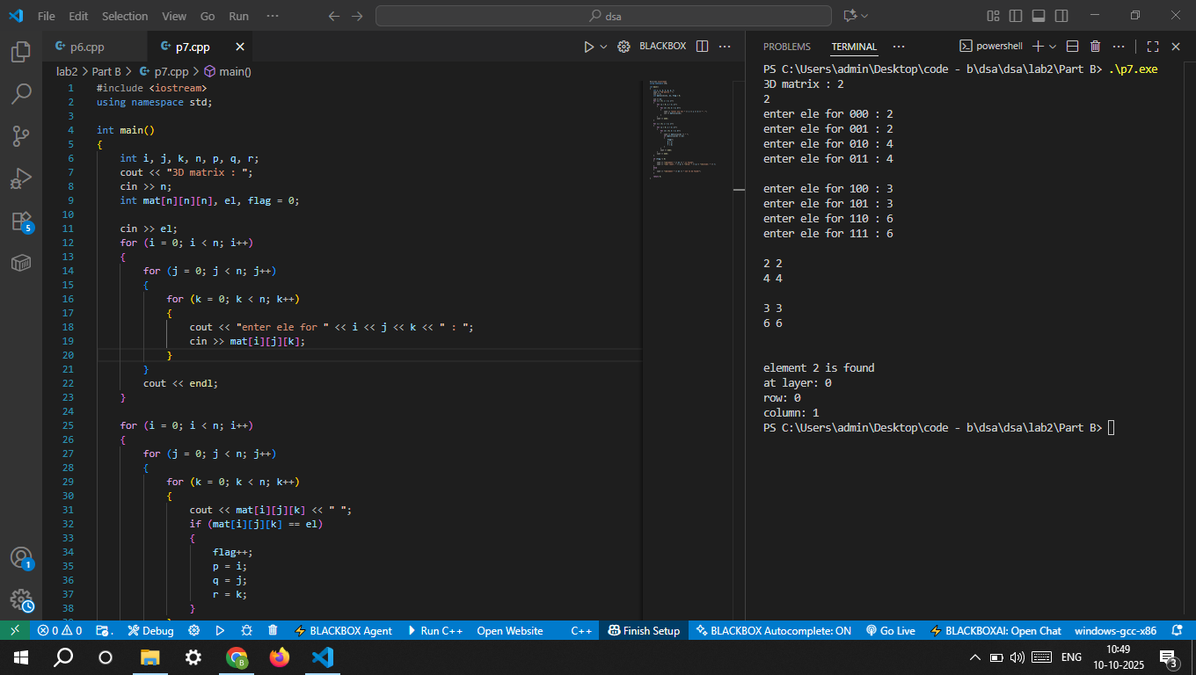

Problem 8: Sum of All Elements in a 3D Array Accept a 3D array of size 2×2×2 from the user. Write a program to calculate and print the sum of all elements.